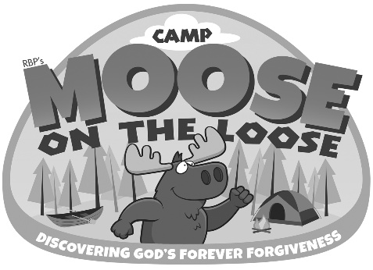

PINE GROVE BAPTIST CHURCH

PARENTAL CONSENT / TREATMENT OF MINOR / DISCLAIMER OF LIABILITY

Your child is being offered the opportunity to participate in our Vacation Bible School program, Moose on the Loose, to be held July 9 through 13, 2018.

The undersigned parent/legal guardian of (Name of Child)________________________________, a minor, does hereby consent to the participation of my child in such activity.

I further authorize Pine Grove Baptist Church as agent(s) for the undersigned to consent to any medical and/or dental care, including any X-ray examination, anesthetic, medical, or surgical diagnosis or treatment and hospital care which is deemed advisable by, and is rendered under the general or special supervision of, any physician and surgeon licensed under the provisions of the Medical Practice Act on the medical staff of any hospital, whether such diagnosis or treatment is rendered at the office of said physician or at said hospital. It is understood that this authorization is given in advance of any specific diagnosis, treatment or hospital care being required but is given to provide authority and power of the part of our aforesaid agents to give specific consent to any such diagnosis, treatment or hospital care which aforementioned physician in the exercise of his/her best judgment may deem advisable. This authorization is given pursuant to the provisions of Section 6910 of the Family Code of California.

The undersigned parent hereby authorizes any hospital or other medical provider which has provided treatment to the above-named minor pursuant to the provisions of Section 6910 of the Family Code of California to surrender physical custody of such minor to any of the above-named agents upon the completion of treatment. This authorization is given pursuant to Section 1283 of the Health and Safety Code of California.

We also agree not to hold responsible Pine Grove Baptist Church or any of its responsible agents for the accidental injury of my child, or the negligent act (s) or intended act (s) made by others, which cause injury to my child.

These authorizations are effective from July 9 through 13, 2018 unless revoked sooner in writing delivered to said agent.

Date __________________

_________________________________________ __________________________ ______________________ Signature of Parent or legal guardian Home telephone Work/Cell telephone

_________________________________________ _____________________________
Alternate Contact Home/Cell telephone

Date of Child’s birth _______________________ Date of last tetanus shot _____________________
If your child is presently taking medication, what is it? ___________________________________________
Medication / Food allergies? _________________________________________________________________
Family Physician ______________________________________ Telephone ___________________________

Name of Insurance Company: ________________________ Policy Number_____________________________

Pine Grove Baptist Church, 5551 S. Bradley Rd., Santa Maria, CA 93455 (805)937-4538

Form is to be used when parents will not be present during the activity.

